**Activitate matematică – Animale sălbatice**

**Formează prin încercuire diverse grupe de obiecte.**

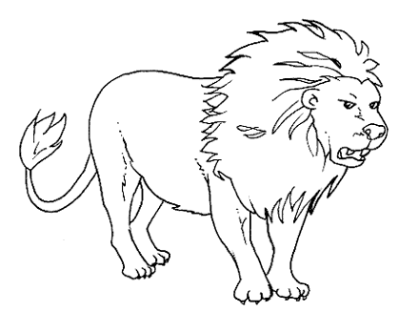

[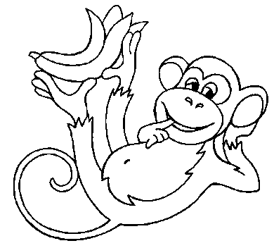](http://www.mescoloriages.com/imprimer.php?img=/coloriages/animaux/dans%20la%20foret/singes%201/images/singe3.gif)

[](http://www.mescoloriages.com/imprimer.php?img=/coloriages/animaux/dans%20la%20foret/singes%201/images/singe3.gif)

